**Dental Care Supply**

**West Virginia (WV) Notes**

**by Chris Larkins**

* Because the WV BOD data required request via email, the BOD data from 4.5.19 on dropbox was used.
* The “IKN_processed.csv” file and “[NP_national_w_extra_col_2n.csv](http://localhost:8888/view/Dental%20Care%20Supply/NP_national_w_extra_col_2n%20(1).csv)” files were used
* Anything that mentioned “hygienist” was disregarded in accordance to receipt dropbox updates.
* I used the PA/IL code on dropbox to help formulate my code for WV
* The ADA report shows 867 dentists in WV in 2018. The final FTE sum of dentists was 856 (850 unique).
  + This number is a bit low. However, I do not believe this number includes any duplicates, and the ADA dentist total for WV in the last 4 years has been on the decline. Therefore, I decided to keep it.
  + Just to make sure, I re-ran the code to include all out-of-state BOD addresses. However, after excluding states with an out-of-state “submitting state”, I got the same exact number of dentists.
  + 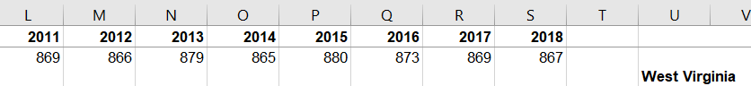
* This BOD file from 4.5.19 includes:
  + 1170 rows of dentists, without any hygienists.
    - 850 unique dentists with WV practice state.
    - 93 dentists with a NULL practice state.
    - All of these licenses are updated/active.
    - The data includes ages, and it is peculiar that several of the dentists have ages in the 70’s and 80’s.
    - The data includes mailing addresses
      * 36 of the dentists with a WV or NULL practice state are listed with a “Yes” under the “Action Indicator” Column. I assume this has to do with disciplinary action, but I decided to keep these dentists.
      * In conclusion, I decided to keep dentists with a WV or NULL practice state, and then filtered for “submit state” is WV in the exclusions phase. For the BOD stand alone, I filtered for WV addresses ony.
  + The Columns Headers Include:
    - *LNAME, FNAME, MI, B ADDRESS, Business CITY, B COUNTY, B STATE, B ZIP, Mailing ADDRESS, M CITY, M COUNTY, M STATE, M ZIP, DEGREE REC, AGE, LICENSE NO, LIC DATE, SPECIALTY, ANESTHESIA, EXPIRATION DATE, ACTION INDICATOR, BOD_names*
* The IKN-NPPES match rate was 98%
* The overall IKN match rate was 91%
* Mostly “Both” rows were present at the end of the exclusions stage. However, because there were some MED and CHIP values, the state was broken down into MED and CHIP. This resulted in a large sum of dentists from all three files since all the “BOTH” dentists were counted twice.